
SUBJECT : software construction and development LAB
TASK NO : 1
NAME : MOIN UD DIN
ID : CU-4365-2023
SECTION:D
DEPARTMENT: SOFTWARE ENGINEERING

Lab Task

- Write a Python program that calculates the area of a circle based on the radius entered by the user.
INPUT :-
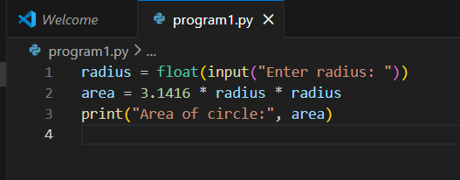

OUTPUT:-
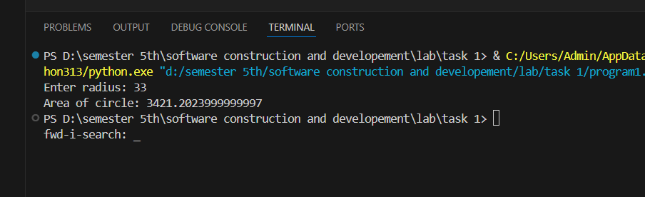

- Write a program to swap two numbers.
INPUT:-
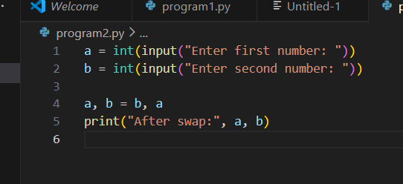

OUTPUT:-
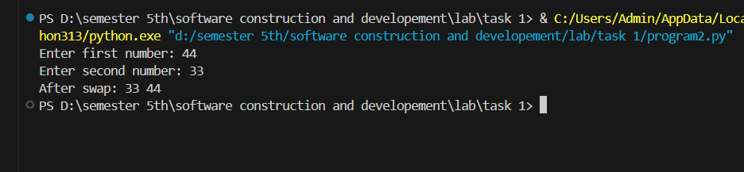

- Write a program to convert Celsius into Fahrenheit. (C*9/5)+32.
INPUT:-
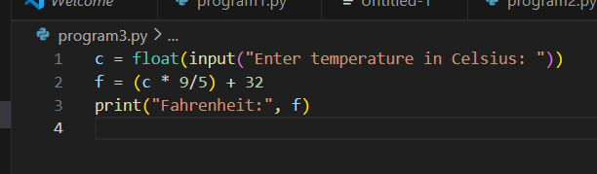

OUTPUT:-
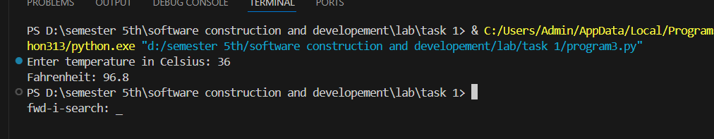

- Write a program which Take marks of 5 subjects and calculate total marks and percentage.
INPUT:-
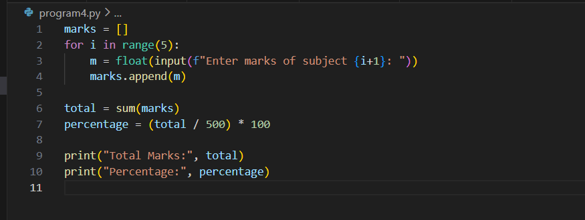

OUTPUT:-
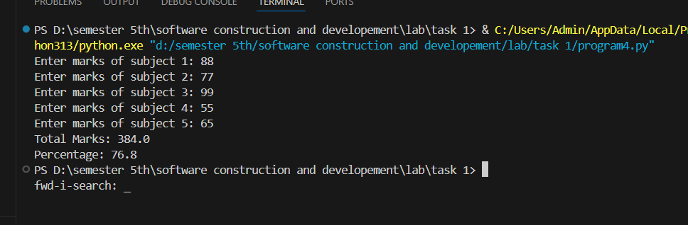

- Write a program to convert an integer into a float and a float into an integer.
INPUT:-
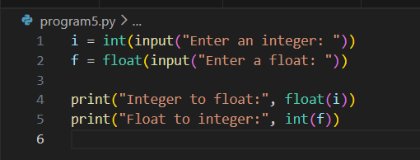

OUTPUT:-
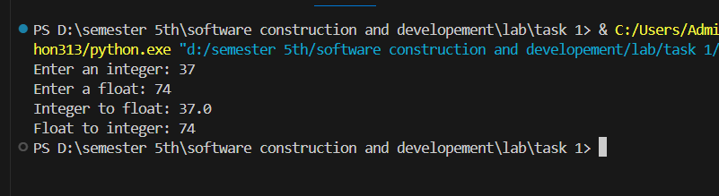

- Create a list of five numbers and print the sum, max, and min values.
INPUT:-
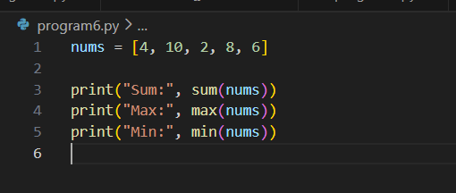

OUTPUT:-
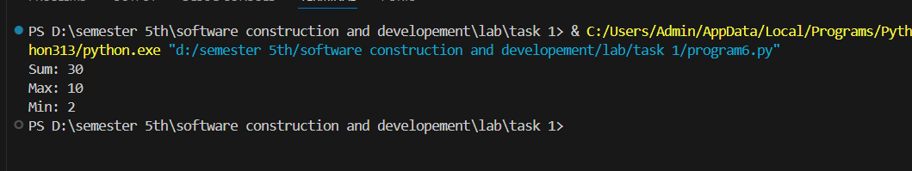

- Write a program to take 5 names from the user and store them in a list.
INPUT:-
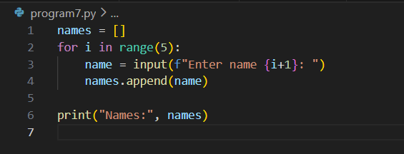
OUTPUT:-
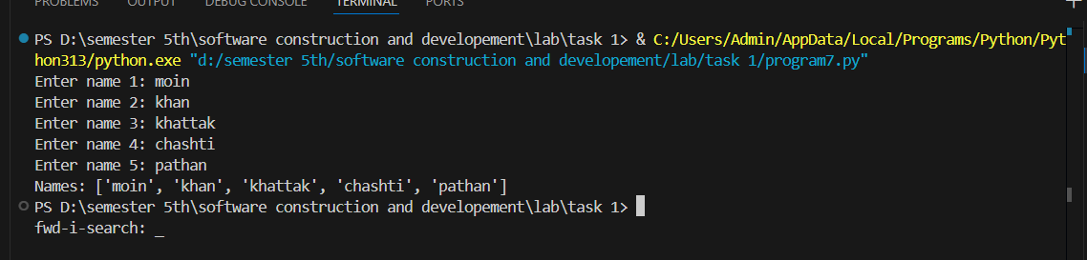

- WAP which Add an element to the end of a list using append().
INPUT:-
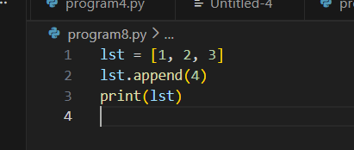

OUTPUT:-
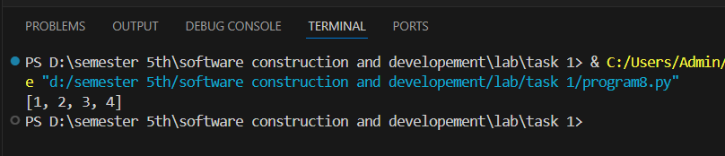

- Insert an element at a specific index using insert().
INPUT:-
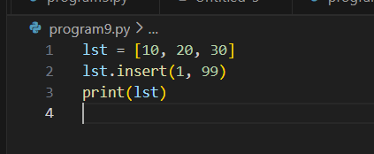

OUTPUT:-
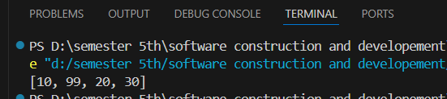

- Remove an element from a list using both remove() and pop().
INPUT:-
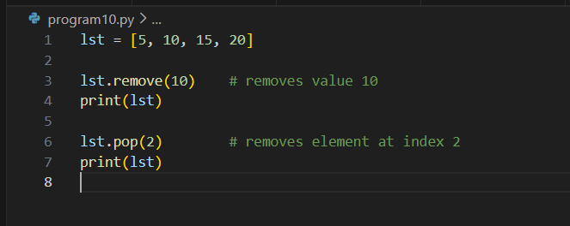

OUTPUT:-
